**Installation guide for Python Fundamentals Course**

1. Installation and Setup of Jupyter notebook

#### The Jupyter Notebook is an open-source web application that allows you to create and share documents that contain live code, equations, visualizations and narrative text. Uses include: data cleaning and transformation, numerical simulation, statistical modeling, data visualization, machine learning, and much more.

#### First of all you need to install Anaconda Navigator software. Anaconda Navigator is a desktop graphical user interface (GUI) included in Anaconda® distribution that allows you to launch applications and easily manage conda packages, environments, and channels without using command-line commands.

Before you install it, you need to download the Anaconda Navigator. Visit the official website, <https://www.anaconda.com/>



Once you open the website, click on the Get Started button.



After getting this page, click on Install Anaconda individual Edition.

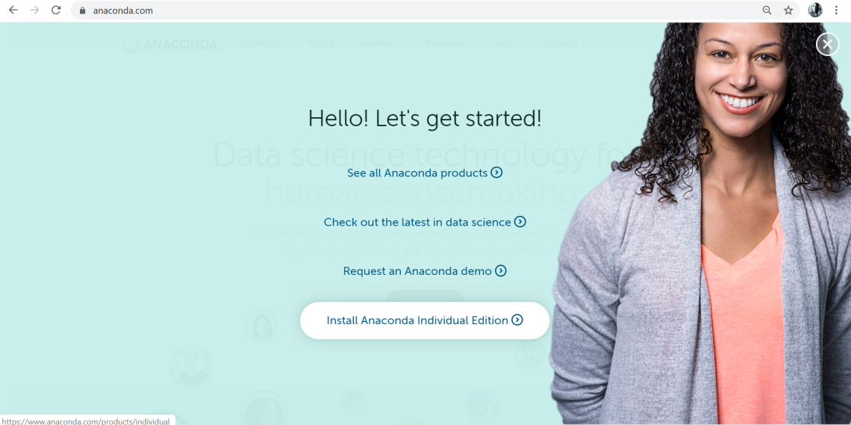

After this, click on the Download button.

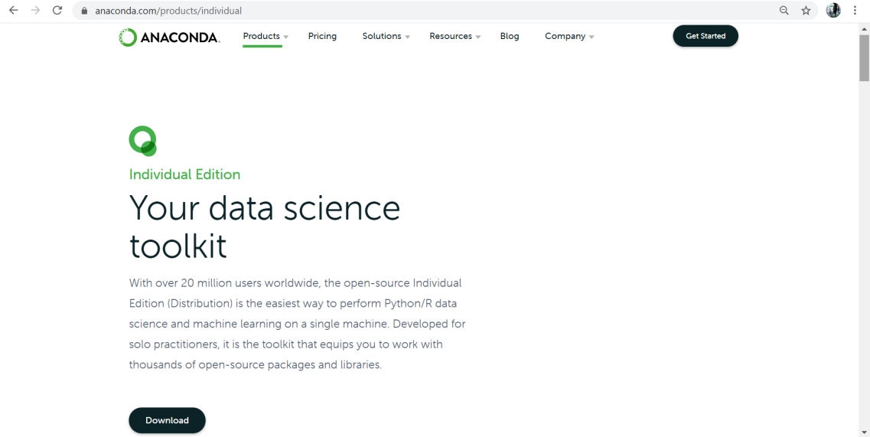

Select the suitable option according to your system(Windows, macOS, Linux) and 64-Bit.

(Here explained for windows)

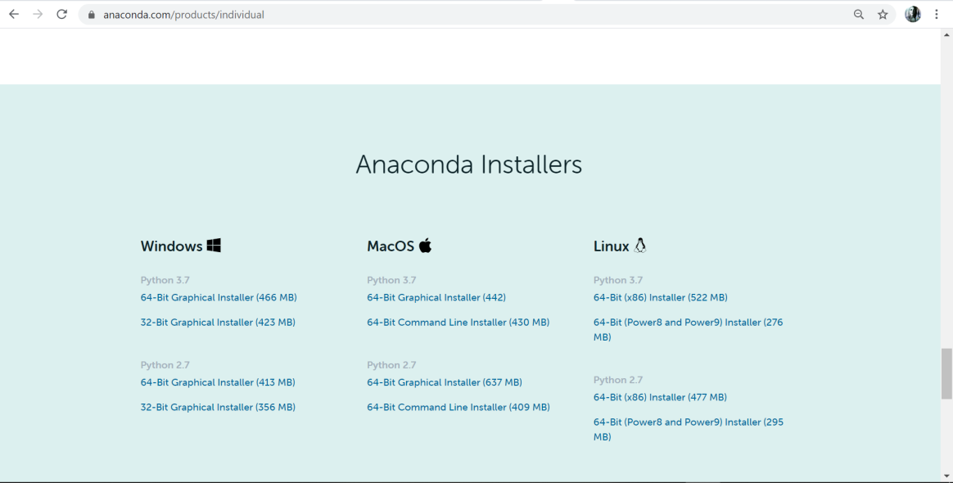

Select the latest version of Python and download it. Once you are done with the download, open the downloaded executable file. When you open the executable file, you will see following window.

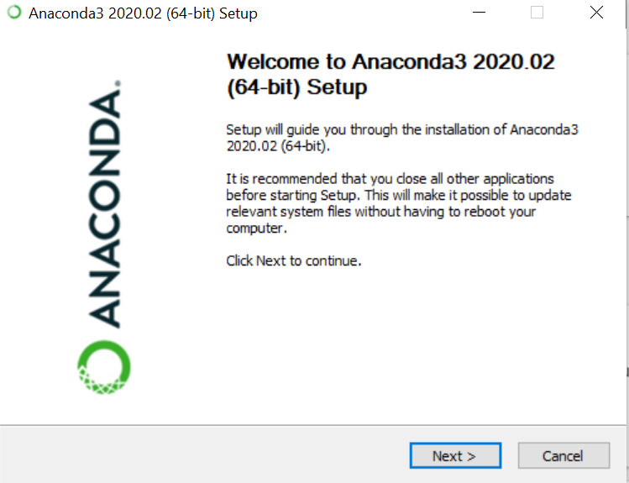

Just click on the Next button.

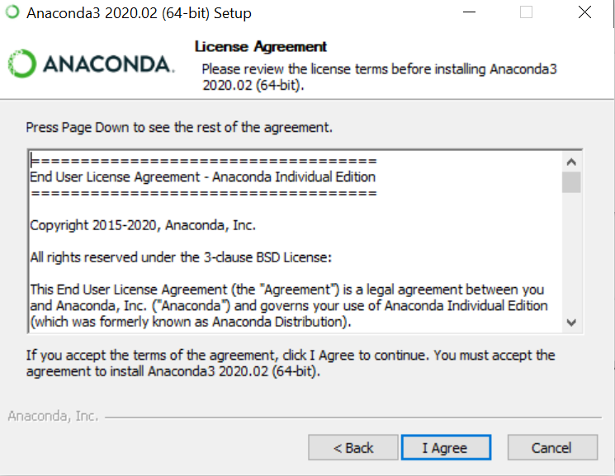

Click on I Agree.

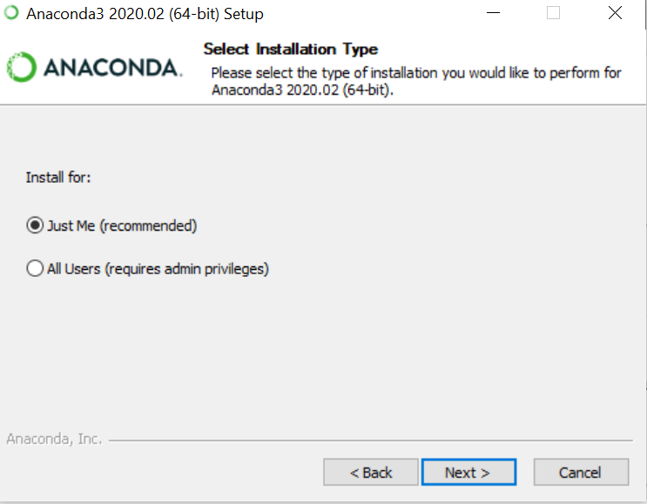

Click on Next.

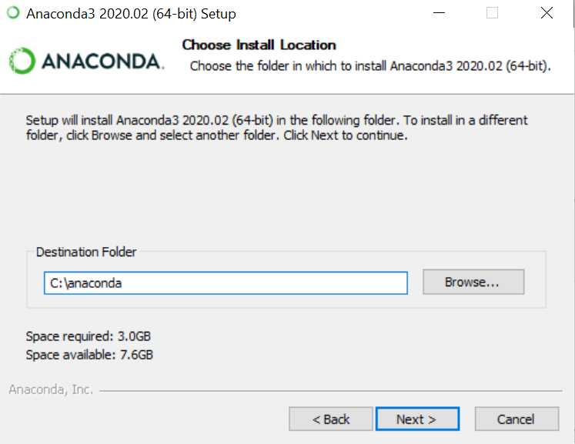

Click on Next.

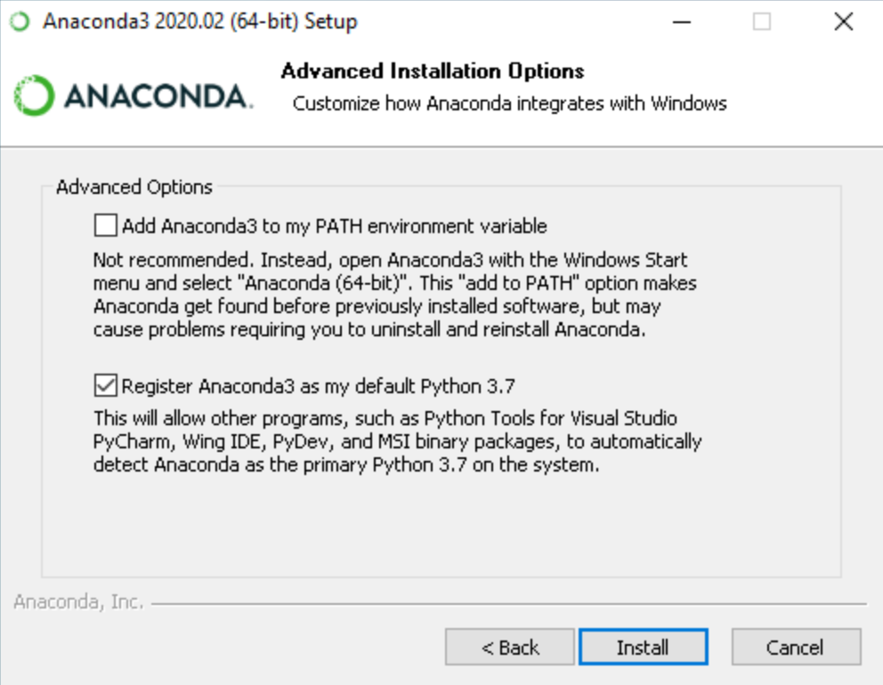

Click on Install.

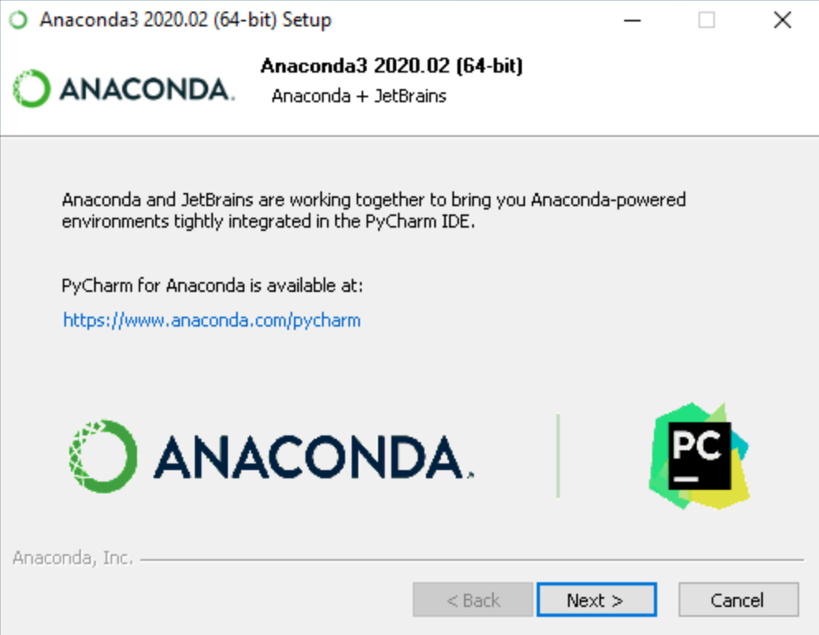

Click on Next.

After installing the Anaconda Navigator, just open it. Once you open it, it will look something like this :

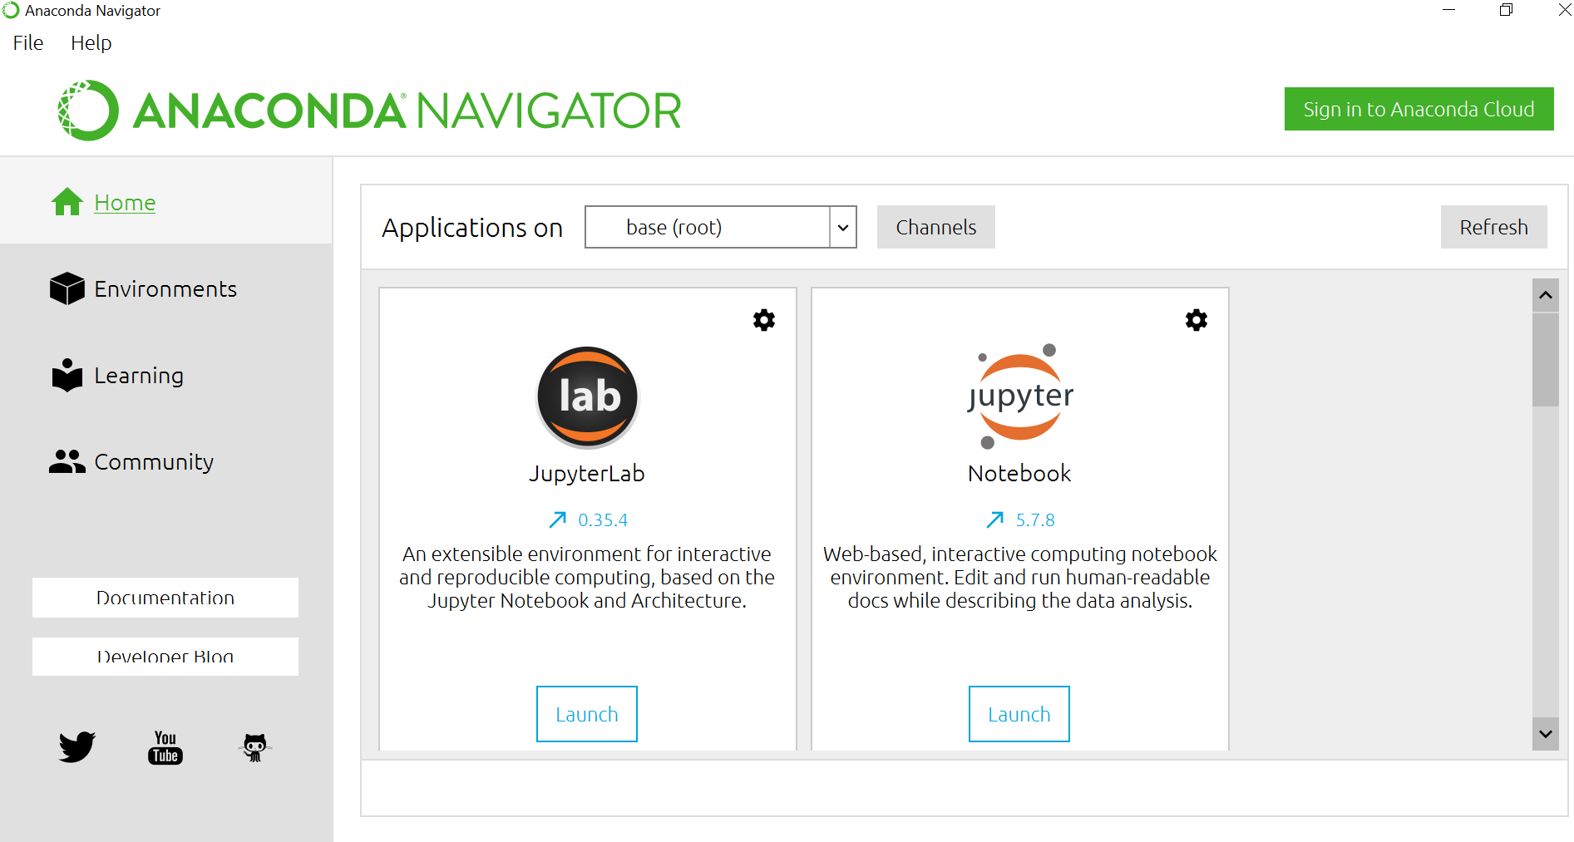

Launch the Jupyter notebook software by clicking on the Launch button.

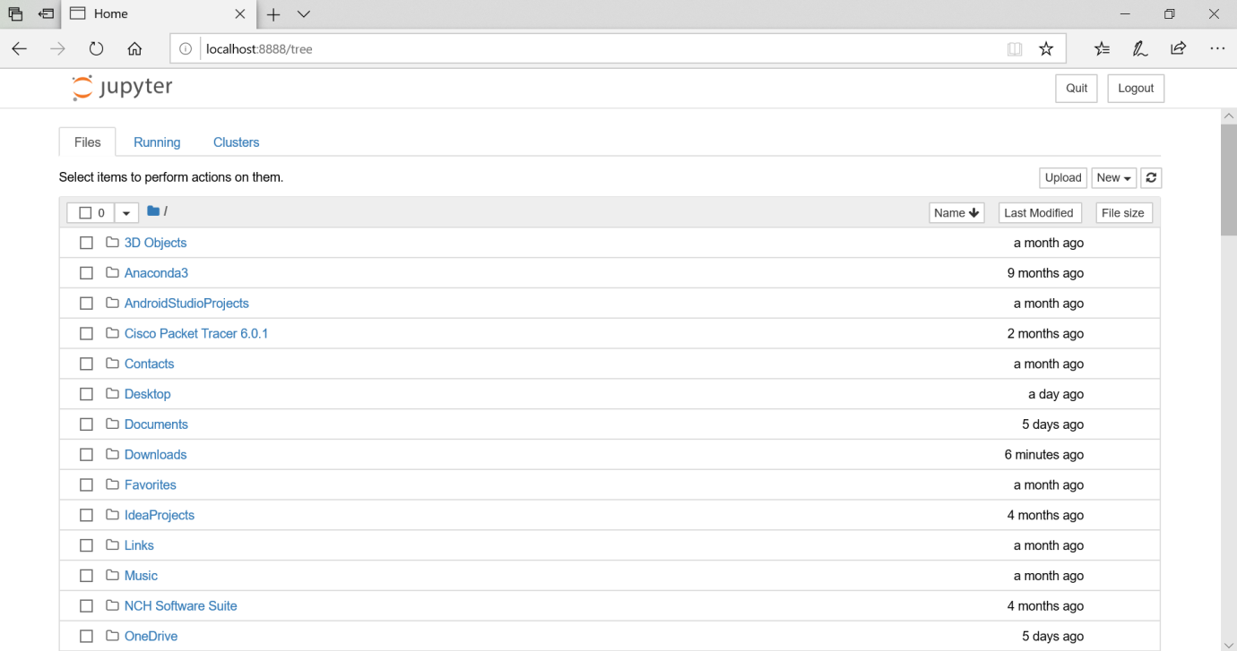

Now you can start coding by creating a new file. To create a new file click on New button.

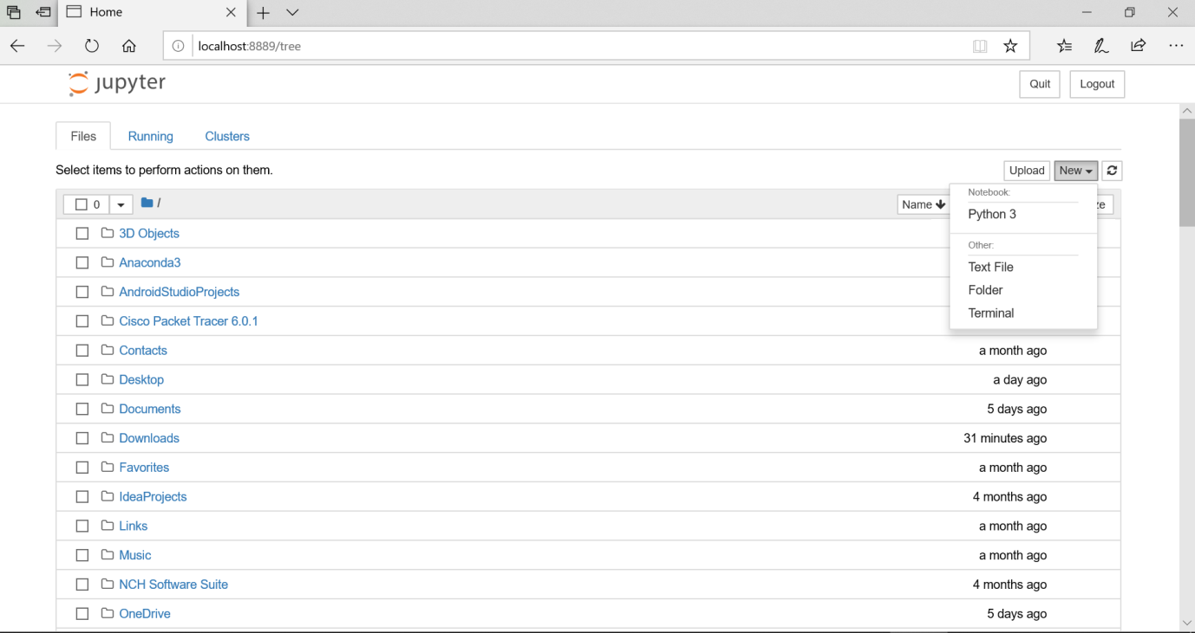

Here select Python 3 to create a new python file.

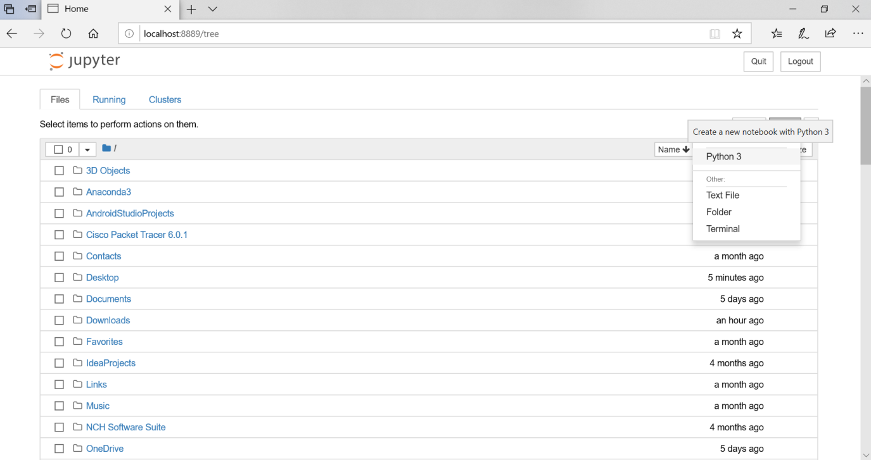

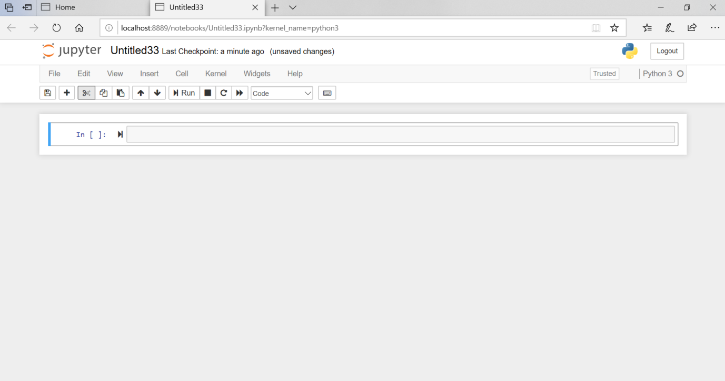

Now you can start coding here. Once you are done with your coding save the file with suitable name and download it in .ipynb format.

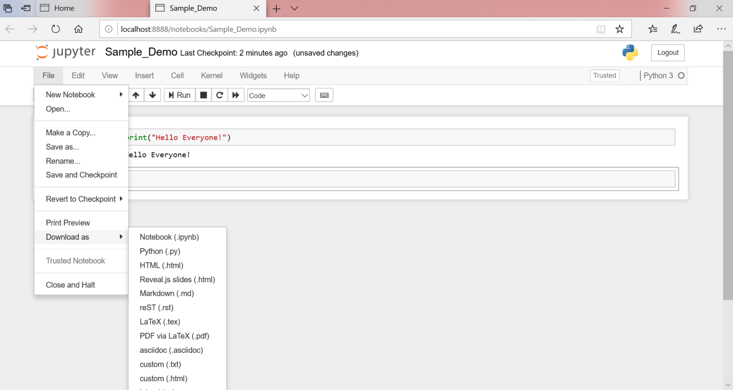

1. How to create github account and github repository ?

github is a code hosting platform for collaboration and version control.github lets you (and others) work together on projects.

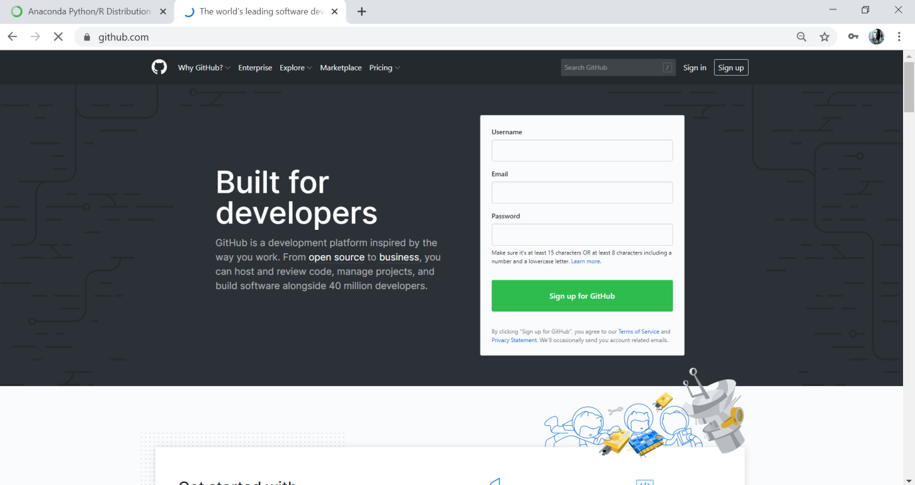

Create a github account and once you create it, every time you can login using your username and password.

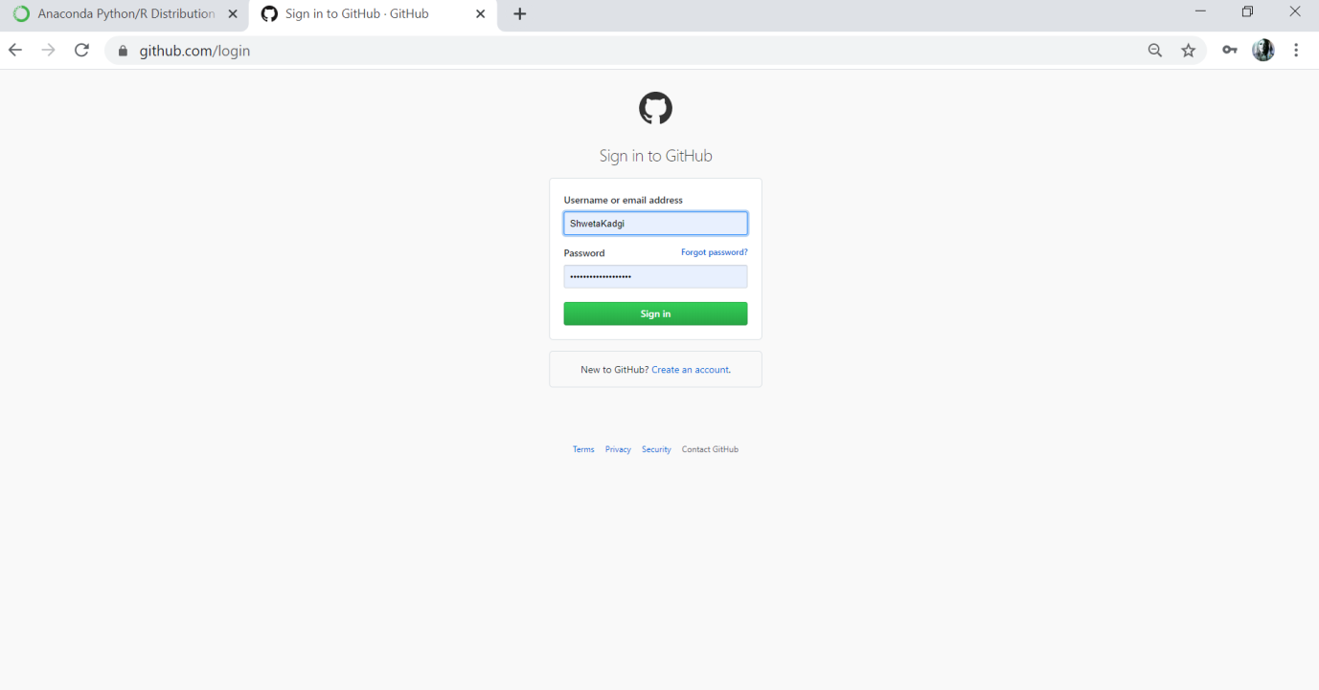

Once you have successfully logged in then just create a new repository by clicking on New button on the top left corner. You can give any suitable name for your repository.

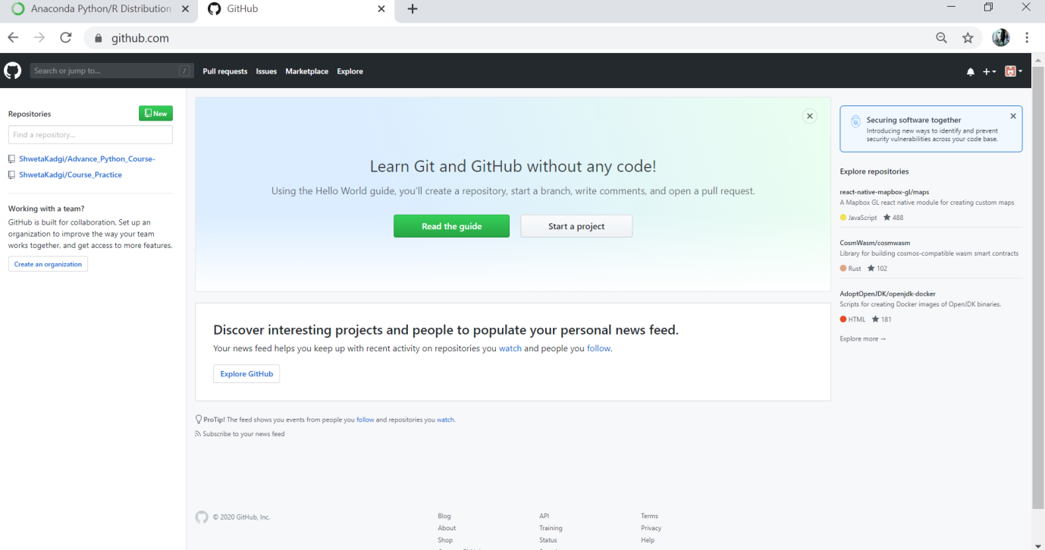

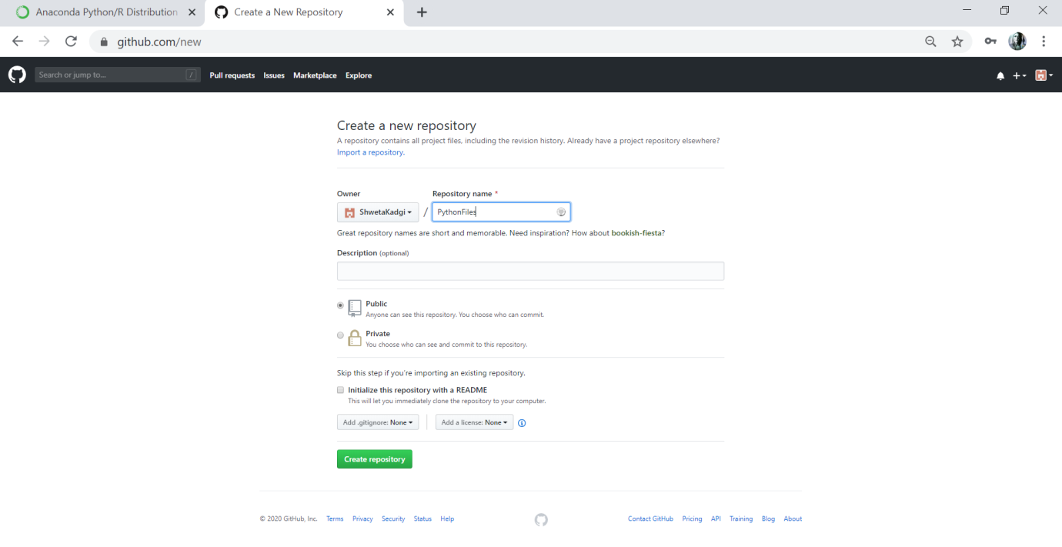

Here I am creating a repository named PythonFiles.

The care that you have to take here is that you must select as public so that anyone can access the github repository once you share the link and don’t select that check box which is as Initialize this repository with a README. After that click on the Create repository button.

You can add description regarding your repository, if you want to. But it is optional. Once you create the repository, now comes the step to upload your python file on github.

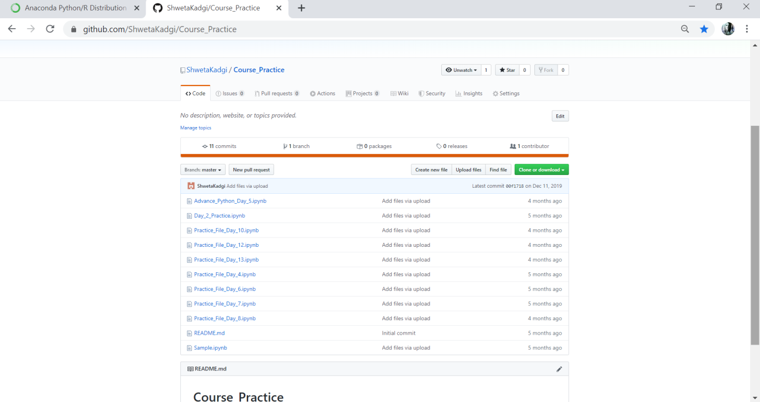

Just click on the Upload files option. As I have uploaded many files already, all the names of the uploaded files are available here.



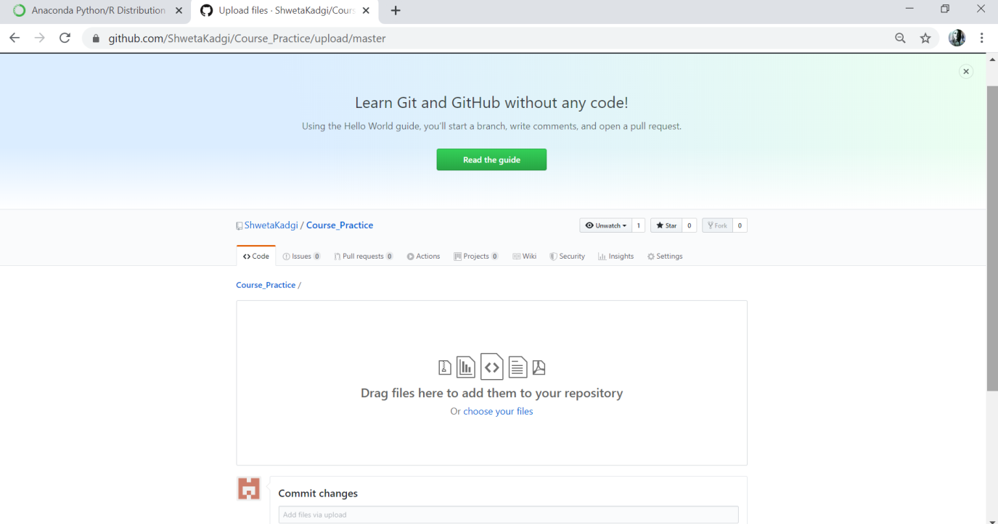

Click on choose your files. Here you select the file that you had downloaded in .ipynb format which will be available in your Downloads folder and after that just click on Commit changes. You have successfully done with the step of uploading the python file on the github repository. Now copy the URL from the address bar of github repository.

1. How to send mail at [codetraining01@gmail.com](mailto:codetraining01@gmail.com)
2. Just paste the link of the git repository in the mail.

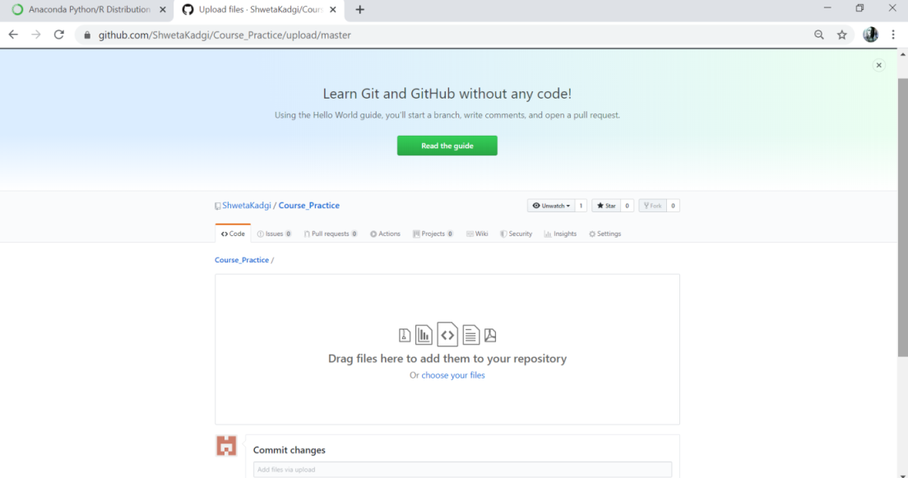

Copy this link and paste in the mail!

1. Ask your queries if you have, along with the screenshot.
2. While sending the mail, don’t forget to mention your batch name along with heading as Python fundamentals Batch as shown below :

Mention your batch name

